//Enumeration

class EnumEx {
public enum Weeks {
MONDAY,TUESDAY,WEDNESDAY,THURSDAY,FRIDAY,SATURDAY,SUNDAY
}

public static void main(String args[]) {
for(Weeks w : Weeks.values())
System.out.println(w);
}
}

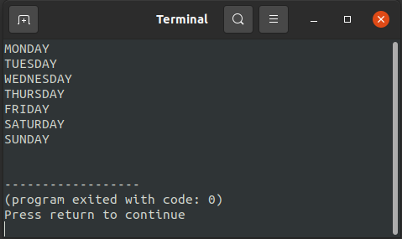
Output:

